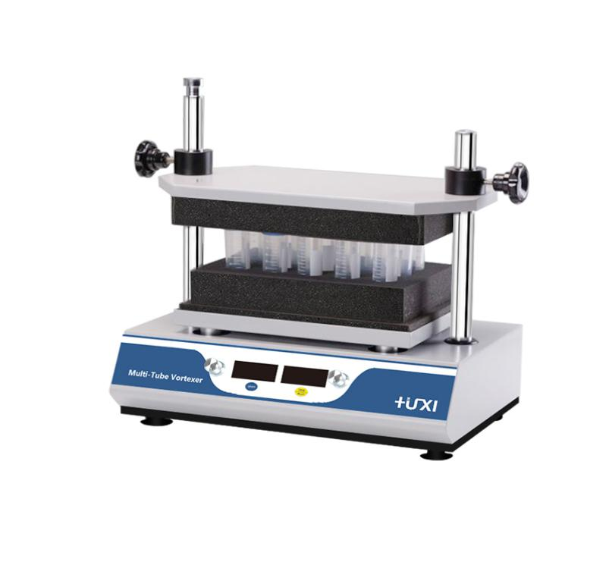

**HT-200 Pulse multiple tube vortex mixer**

**1、Applications**

The HT-200 multi-tube vortex mixer adopts DC brushless motor and microcomputer control technology. The unique knob operation mode is simple and easy to use. By changing different test tubes to fix the sponge, it can mix and cultivate various commonly used test tubes, and up to 50 samples can be mixed at one time. Suitable for fields such as biotechnology, microbiology and medical analysis.

**2、Features**

1. One-button knob operation mode, easy to use；
2. Set the time arbitrarily within the range of 1min~99h59min, and automatically emit a prompt tone after the operation is over;
3. A variety of sponge test tube racks are available for a wide range of uses；
4. Soft start, uniform acceleration, effectively avoid sample splash；
5. Driven by DC brushless motor, precise speed, long life, maintenance-free；
6. Up to 50 test samples can be processed at a time, making the experiment efficient and fast；
7. Simple operation panel, precise control of micro-processing volume, real-time LED display of speed and time；
8. Humanized programming, built-in jog and timing operation modes.

**3、Technical Parameters**

|  |  |
| --- | --- |
| **model** | **HT-200** |
| **Rotating speed** | **500-2500rpm** |
| **Amplitude** | **4mm horizontal rotation** |
| **Time setting** | **1min~99h59min** |
| **Sample size** | **See the optional test tube rack below** |
| **Maximum load** | **4.5kg** |
| **Input power** | **70W** |
| **Dimensions** | **410*276*432mm** |
| **Weight** | **20kg** |

**3、Optional test tube rack**

|  |  |  |
| --- | --- | --- |
| **Model** | **Test tube rack specifications** | **Trial test tube specifications (outer diameter)** |
| **HT200-T22** | **15 holes￠22** | **Applicable scope 22-25mm** |
| **HT200-T14** | **50 holes￠14** | **Scope of application 14-17mm** |
| **HT200-T9** | **50 holes￠9** | **Applicable scope 9~13mm** |
| **HT200-T18** | **50 holes￠18** | **Scope of application 18~21mm** |
| **HT200-T26 (standard configuration)** | **15 holes￠26** | **Applicable scope φ26-32mm** |